* We designed our PCB modularly. Chassis and PCBs are separate.
* We designed a dual-core system with two stm32 embedded chips to simplify coding, speedup sensor collecting rate, and leave redundancy for future sensor data integrating and processing algorithms.
* CubeMx: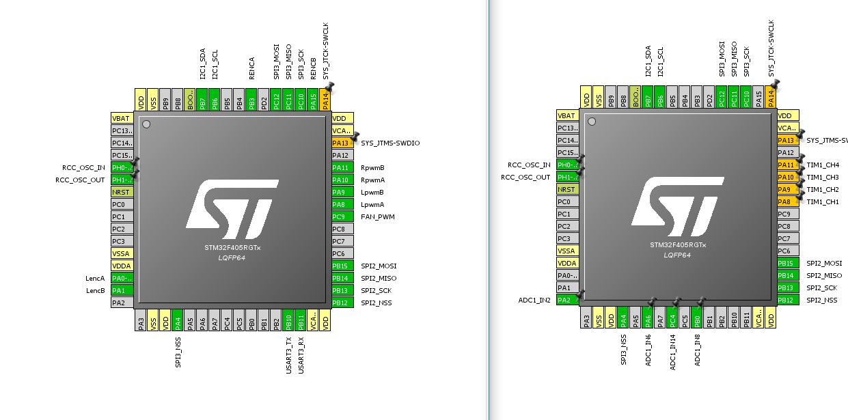
* Main_MicroController’s PCB Schematics and board layout: 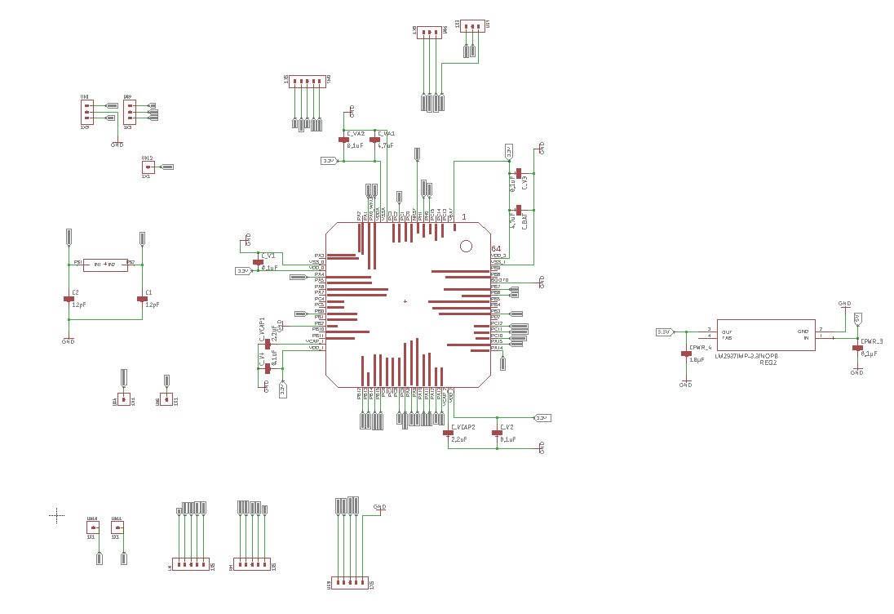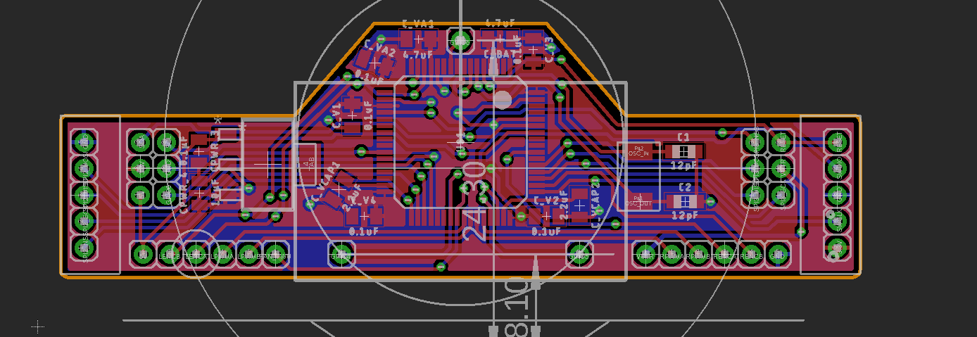
* SensorProcessing_Microcontroller’s PCB Schematics and board layout 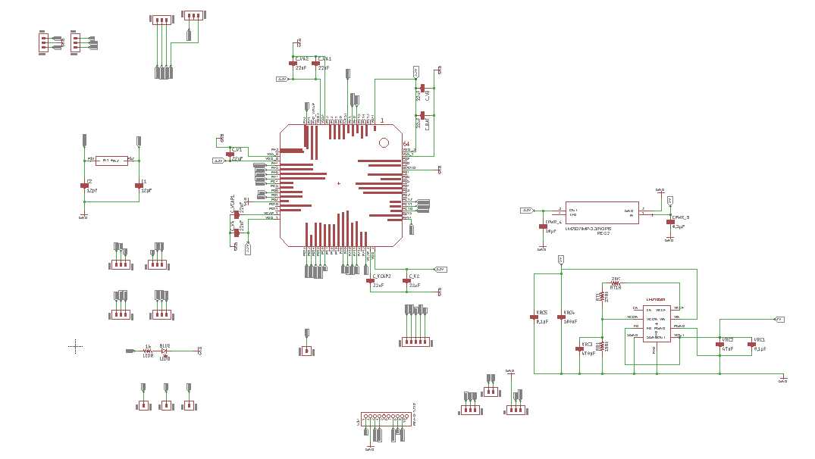 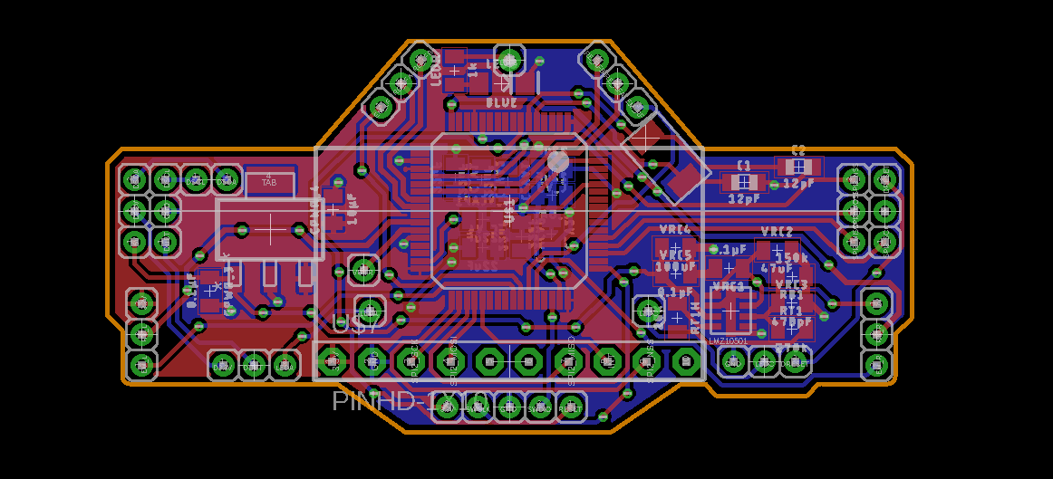
* Motor Controller and voltage Regulator(5v LDO)’s PCB Schematics and board layout 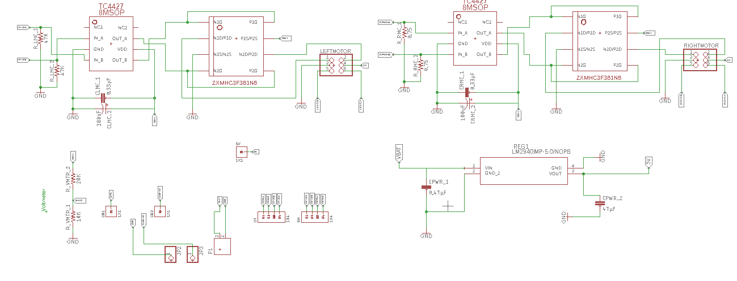 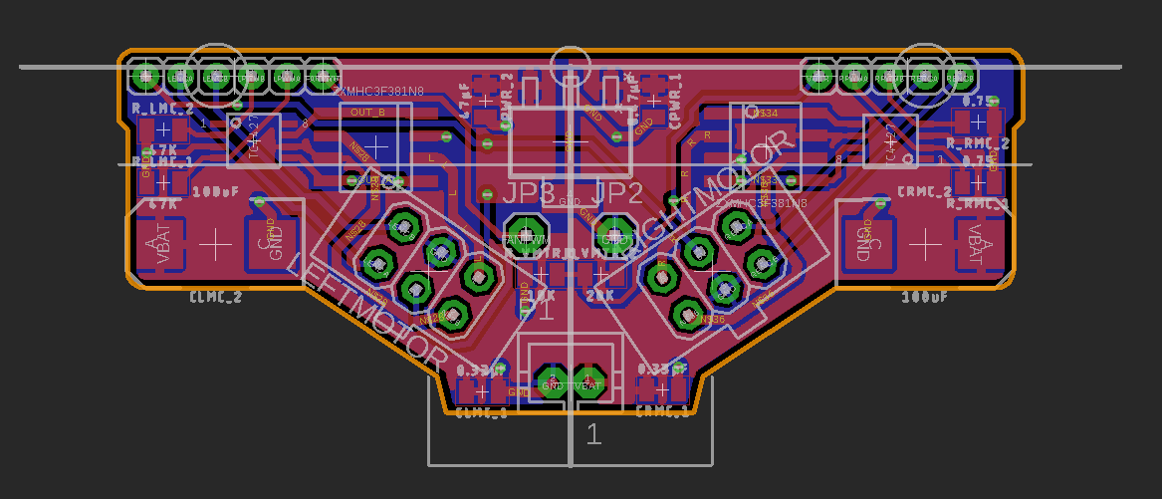
* LEDs & Switches & Buttons PCB Schematics and board layout 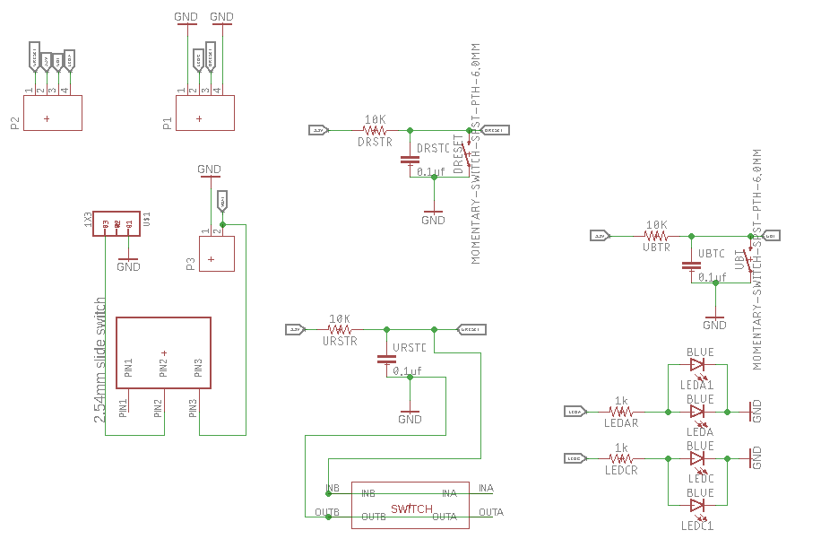 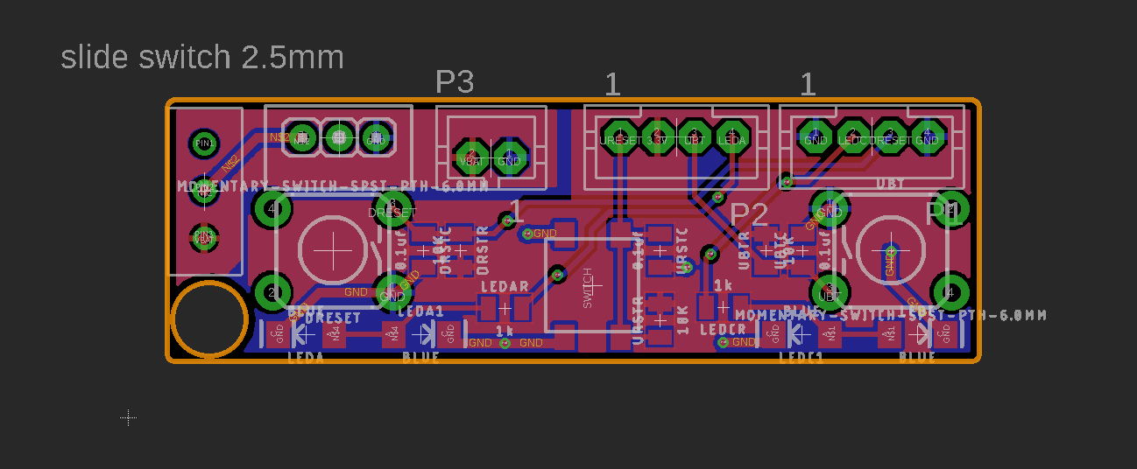
* IR Module A(1 Emitter & 1 Receiver) 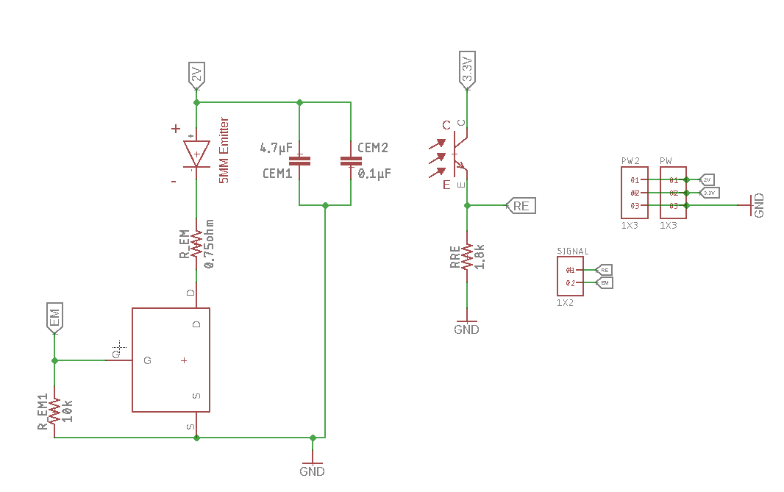 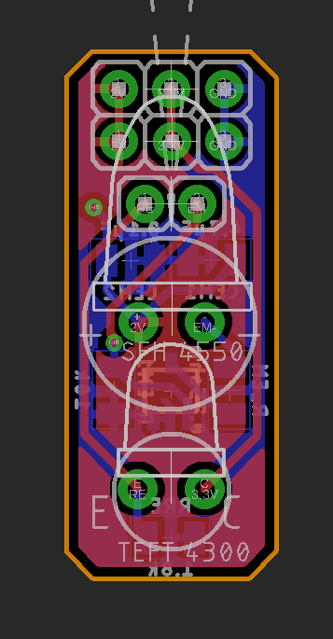
* IR module B(1 Emitter & 2 Receivers)